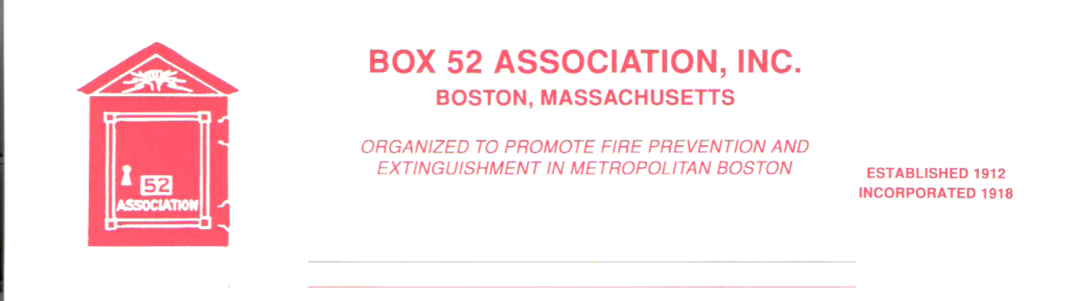
OFFICERS DIRECTORS
PRESIDENT Richard A. Conway Frank Barry
richardaconway@comcast.net Thomas Brophy
VICE James Cullen Michael Kass
PRESIDENT jandm0603@hotmail.com Patrick O’Connor
SECRETARY Jeff Brown David Parr
box52 secretary@gmail.com John Rafferty
TREASURER William H. Wilderman – 617-212-8186
Bwilderman@feinewengland.com
Mailing Address:
Box 52 Association
Website: www.Box52.org c/o William H. Wilderman
E-Mail: box52boston@hotmail.com PO Box 848
Medford, MA. 02155-0009

Celebrating the sesquicentennial of the sounding of Box 52 November 9th, 1872

General Order # 1,073 April, 2022

DATE: Friday April 22nd, 2022

LOCATION: St. Teresa of Calcutta Church
Former St. Margaret’s
800 Columbia Rd. Dorchester
Nearest box 7252 Columbia Rd & Dorchester Ave.

TIME: 2000 Hours Meeting

PROGRAM: “B.F.D. the War Years” with guest speaker BFD
Retired Lt. Mike Foley.

March Meeting
40 members and guest attended our first in person meeting in a long time. Mr. William Ladell of the FDNY Field Communications Unit presented a very interesting program on the Field Comm, FDNY Bureau of Communications and the FDNY. He answered many questions from the audience.

April Meeting
With our March meeting we are resuming in person meetings! Our meeting will take place in Boston at St. Teresa of Calcutta Church 800 Columbia Rd. This is the former St. Margaret’s. Parking can be found in the rear of the church. Access from Roseclair Street. Additional parking in the school lot out front and in the rear. Please use the rear entrance of the church for our meeting. There is an alley between the school and the church to walk to the rear church entrance.
Our guest speaker will be retired BFD Lt. Mike Foley. He will be presenting a look at the BFD during the War Years. This should be a very entertaining meeting. Please make every effort to attend.

Membership
The second reading of applicant David Traiforos will be read and voted on at the upcoming meeting.

By Law Announcement
Per the Association’s Bylaws, at the April meeting the membership will be asked to vote on moving the sum of $ 2,000.00 from the Permanent Fund to the Operating Fund to cover Audio-visual equipment to allow the live streaming of meetings and to cover expenses that are not covered by dues.

Good and Welfare
Condolences to member Paul and Gerard Mahoney on the loss of their mother Mary Jane. May her soul rest in peace.

Ham & Bean Supper
The Ham & Bean supper will be on May 20th at the Erie No. 4 in Georgetown. The guest speaker will be Mr. James Regan of Chicago who will be presenting another interesting and informative show. Ticket will be on sale at the meeting and the cost will be $ 15.00 per person. See Treasurer Bill Wilderman for your ticket(s)!

Bus Trip
The Board of Directors along with the Trip Committee have voted to hold off on the bus trip to the South Shore until next year, due to the IFBA Convention being held two weeks later.

Reminders

- Friday April 22nd in person meeting 2000 hrs. St Teresa of Calcutta 800 Columbia Rd.
With guest speaker BFD Lt. Mike Foley ret. “B.F.D. the War Years”
- Tickets for the Ham & Bean Supper on sale $ 15.00 per person

By Order of the President Newsletter Editor
Richard Conway Frank San Severino

