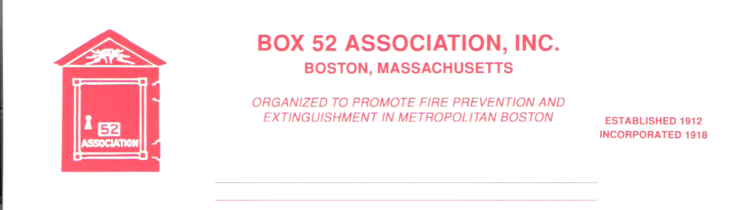
OFFICERS DIRECTORS
PRESIDENT Frank Barry Thomas Brophy
fbrfd@yahoo.com James Cullen
VICE Richard A. Conway Michael Kass
PRESIDENT richardaconway@comcast.net Pat O’Connor
SECRETARY Jeff Brown David Parr
jeffb0841@gmail.com John Rafferty
TREASURER William H. Wilderman – 617-212-8186
Bwilderman@feinewengland.com
Mailing Address:
Box 52 Association
Website: www.Box52.org c/o William H. Wilderman
E-Mail: box52boston@hotmail.com PO Box 848
Medford, MA. 02155-0009

General Order # 1,054 October 2020

OCTOBER 16TH FIRST VIRTUAL MEETING!

Date: Friday October 16, 2020

Location: Virtual via Google

Time: 2000 hours

Program: Annual Meeting and presentation by
member Michael Boynton of apparatus from the
late Bryon Hurst collection.

Virtual Meeting
This meeting is going to be very different than any other in the history of the Association. Vice President Conway has secured use of the IFBA’s virtual meeting host program. This will enable us to have the annual meeting conducting the business of Association and the annual election. The instructions for the use of the Google platform will be on page 3 of this G.O. If you have used Zoom for meeting during the Pandemic, than you should be able to adept rather easily to this platform. For anyone having issues, please reach out to V.P. Conway for assistance. THE TIMES LISTED ARE FOR CENTRAL TIME ZONE AND ARE ONE (1) HOUR BEHIND EASTERN TIME. THE 1900 HOUR START IS ACTUALLY 2000 HOURS!

Nominations of Officers
The slate of officers put forth by the Nominating Committee is:
President: Richard Conway
Vice President: James Cullen
Secretary: Jeff Brown
Treasurer: William Wilderman

Membership
The following three members have accepted the invitation of the Board to Life Membership:
Robert Fitz Jr., John Gallagher, Wayne Perkins. Congratulations.
The Board will interview virtually 3 members on the Waiting List to fill these vacant positions.

Annual Reports
Attached with this G.O. are the Annual Reports of the Officers and the Newsletter Committee. The Treasurers report is not included as the Auditing Committee has not had an opportunity to meet due to the Pandemic.

Line Box
The first issue of the Line Box will be out shortly. This is reported to be another jam packed issue, that we hope you all enjoy.

I.F.B.A.
The Box 52 delegates for the Virtual IFBA Business meeting are:
Delegate: Richard Conway
Alternate: John Rafferty

By Order of the President Newsletter Editor
Frank Barry Frank San Severino

INSTRUCTIONS FOR ACCESSING THE VIRTUAL MEETING

Box 52 Meeting

When | Fri Oct 16, 2020 7pm – 10pm Central Time - Chicago
Joining info | Join with Google Meet
 | meet.google.com/zwm-xjfk-jep
 | Join by phone
 | (US) +1 432-756-7230 (PIN: 633420239)
 | More phone numbers
Calendar | richardaconway@comcast.net

To join the meeting just enter the meet.google.com link above. You should have a camera on your computer, but it is not necessary. You can also call in at the above listed phone number and take part. Just remember to put the above pin code in when prompted to do so. Any questions, ask Rick. Hope to see you all on the 16th!

Proper virtual meeting conduct:
- Keep your mic on mute, unless you need to speak
- Raise your hand to be acknowledge to speak
- Please bring plenty of patience as this is new to all of us!
- Let’s enjoy another first in the rich history of the Box 52 Association!

