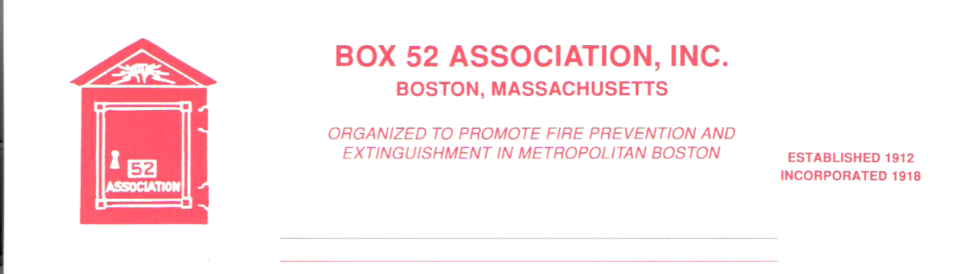
OFFICERS DIRECTORS
PRESIDENT Richard A. Conway Frank Barry
richardaconway@comcast.net Thomas Brophy
VICE James Cullen Michael Kass
PRESIDENT jandm0603@hotmail.com Patrick O’Connor
SECRETARY Jeff Brown David Parr
jeffb0841@gmail.com John Rafferty
TREASURER William H. Wilderman – 617-212-8186
Bwilderman@feinewengland.com
Mailing Address:
Box 52 Association
Website: www.Box52.org c/o William H. Wilderman
E-Mail: box52boston@hotmail.com PO Box 848
Medford, MA. 02155-0009

General Order # 1,067 October, 2021

DATE: Friday, October 15th, 2021

LOCATION: Brookline Fire Training Academy
Rear of Station 6 962 Hammond Street

TIME: 2000 hours

PROGRAM: History of the Brookline Fire Department
By retired Chief John Spillane

DIRECTIONS TO MEETING SITE
Take 128 to Route 9 Boylston Street towards Chestnut Hill. Follow Route 9 to the Hammond Pond Parkway and turn right onto the Parkway. Follow to the rotary, all around the rotary on to Hammond Street, station is on the right side and the Training Academy is at the rear of the station.

October Meeting
We will be the guests of the Brookline Fire Department arrange by Assistant Chief, and Box 52 member Keith Flaherty. Our speaker is Retired Chief of Department John Spillane who will present a program on the history of the Department.
Chief Spillane was appointed to the Fire Department in May of 1977 and retired as Chief in September of 2003.
This is the first time in many decades that Box 52 will be the guests of Brookline Fire. This is also the annual meeting of the Association.

September Meeting
27 members attended the first in person meeting in over 19 months! Once again, our friends at Mass. Task Force 1 presented an interesting program on their response to the Champlain Towers South collapse in Surfside, Florida. The program was enjoyed by all.

Good and Welfare
Congratulations to member Richard Patterson on his recent promotion to Chief of Department in Dracut.

Membership
Member Paul Boudreau has been named a Life Member by the Board of Directors.
At the October meeting, members will be asked to vote on applicants Edward Loder and Denis Ring.

Dues
Please make sure that your dues are paid promptly. Any member having difficulty is asked to contact any Officer for assistance. Dues are $ 35.00 per year.

Election of Officers
Nominating Committee-Chairman Peter Aloisi presents the following slate of Officers for the 2021-2022 year:
President-Richard Conway
Vice-President-James Cullen
Secretary-Jeff Brown
Treasurer-William H. Wilderman
Director for 1st term-Frank Barry
Director for 2nd term-Tom Brophy

Nominations will be taken from the floor at the meeting.

Line Box
Volume 18 of the Line Box will be out in mid-October. Again it will be another feature packed issue.

Reminders
- In person meeting at Brookline Fire Training Academy, rear of Engine Company 6’s quarter’s 962 Hammond St.
- Pay your dues as soon as possible.

By Order of the President Newsletter Editor
Richard Conway Frank San Severino

