Box 52 Summer Reading Article

The First Boston Rescue Company?
By The Staff of the Line Box

Over the years I had heard that the B.F.D ran a Wrecker as a quasi Rescue Company out of the quarters of Water Tower 2 at the old Bristol Street Headquarters. After some phone calls and some fast research, which I submit for spirited discussion among our members.

As we know the first organized Rescue Company was created by the FDNY in 1915. I found the first mention of an Emergency Truck was requested by Supervisor of Apparatus Charles W. Stewart was in the 1916 Annual Report of the Boston Fire Department.

The truck was purchased and placed in-service in 1917. The apparatus was built on a 1917 Mack AC chassis. It had a weight of 12,500 pounds. It was under the charge of the Supervisor of Apparatus and was manned by four firefighters. The capacity of the truck was 3.5 tons and it is fitted with a five ton power winch capable of lifting five tons. It was equipped with jacks, blocks, several acetylene cutting torches, and other assorted tools for emergency rescue work, including Drager masks! It also carried a supply of gasoline and lubricating oil for motor apparatus working at fires. It was assigned to respond to all multiple alarms and could be called out to anywhere in the City.

On June 15, 1917 Rescue Company 1 was established at the quarters of Ladder 8, using a 1911 American La France combination wagon. It was equipped with six dragger smoke helmets, axes, lifelines, fire extinguishers, elevator rescue kit, and oxygen and acetylene torches and a Pulmotor.

So here we have two Companies with very similar rolls established mere months apart. But, one carrying what today would be considered heavy rescue equipment and the other equipment that might be found on an Engine Squad. And to make it even more confusing here is a copy of an article that was published in the October 1920 issue of “The American City” Magazine. And we have more questions than answers:
- Did these two Companies work together on the fire ground?
- Was the Emergency Truck dispatched to entrapments, and other heavy rescue calls? If so, who responded with them?
- What types of incidents was Rescue 1 dispatched to? Records show that most extrications and some rescue work was carried out by the Ladder Companies. This was especially true of the Downtown and industrial area districts. We know that the Rescue functioned as, for lack of a better term as an early Haz-Mat unit responding to calls involving chemicals, illuminating gas, and the ever present refrigeration ammonia leaks.

WRECKING TRUCKS FOR FIRE DEPARTMENTS
Derrick Trucks Indispensable to Municipalities
(Article copied from original)

The numerous services which up-to-date fire departments are called upon to render require not only the standard fire department equipment but the apparatus of the rescue squad and other types of emergency equipment.

The Fire Department of Boston, Mass. has had a derrick wrecked mounted on a specially built Mack auto truck equipped with a 4-cylinder, 70 horse-power motor. This piece of apparatus has rendered particularly efficient service since it was installed in Fire Headquarters on Bristol Street about two years ago. The machine can make a speed of 40 to 45 miles per hour and is equipped with a power winch and derrick at the end, which is capable of lifting a weight of 10 tons. Among the ordinary uses to which the derrick can be put are towing in wrecked apparatus, delivering fuel and pulling down walls at fire ruins. It has also been frequently used to rescue horses that have fallen into holes or ditches. The wrecker can pick up a heavy automobile and swing it around as if it were a baby carriage. The machine has a record of several hundred accident cases and now averages almost a dozen calls a week.

Among the specific instances of the usefulness of the Boston truck are the following: It was used to convey divers and their outfits from the Charlestown Navy Yard to Fenway Pond, Back Bay District of Boston, the scene of a drowning accident, assisted by Ladder 15. This same machine removed a horse and cart that had fallen over an embankment and into the cellar of a building. The wrecked was used to rescue a horse that had gone through a barn floor on Blue Hill Avenue. It also responded to a fourth alarm from a box on Battery Wharf on the water-front and removed two fire department horses that had fallen into a trench. The wrecker responded to a call from Dorchester, where assisted by members of Ladder 27, it removed a horse from a manhole, the horse being the property of the City of Boston Sanitary Service.

The above are a few of the outside jobs done by the wrecker and do not include the regular fire department emergency work, which are performed quietly. Efficiently and without any special notice being made of it—it’s all in a day’s work for the wrecker.

Boston was the first city to install this type of machine, and since it has been established it has been adopted in a number of other cities. The wrecker was designed by Charles W. Stewart, Supervisor of Motor Apparatus of the Boston Fire Department and was built by the Mack Company. The wrecker is in reality a traveling repair and machine shop and responds to all third alarms. The motor squad is comprised of six men, and three men are kept on night duty.

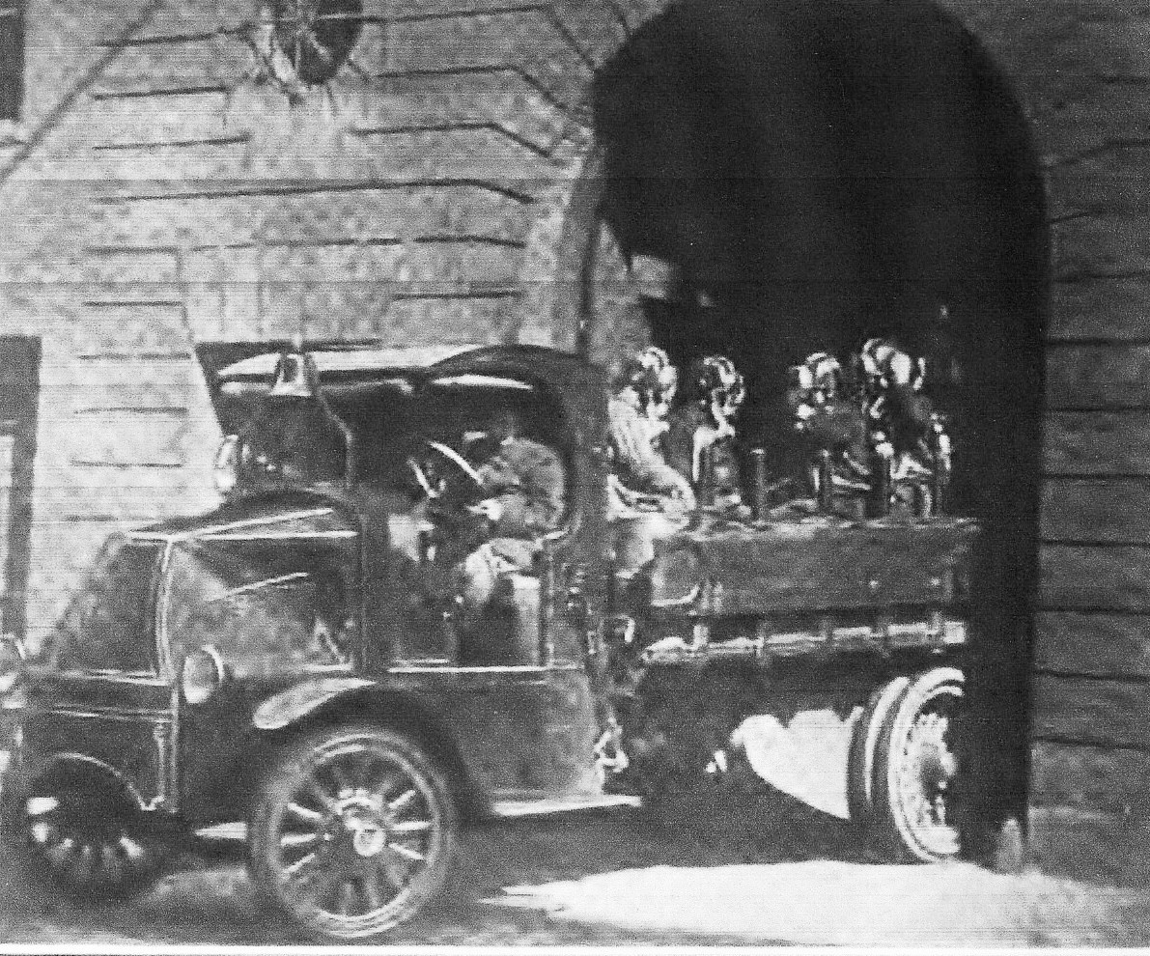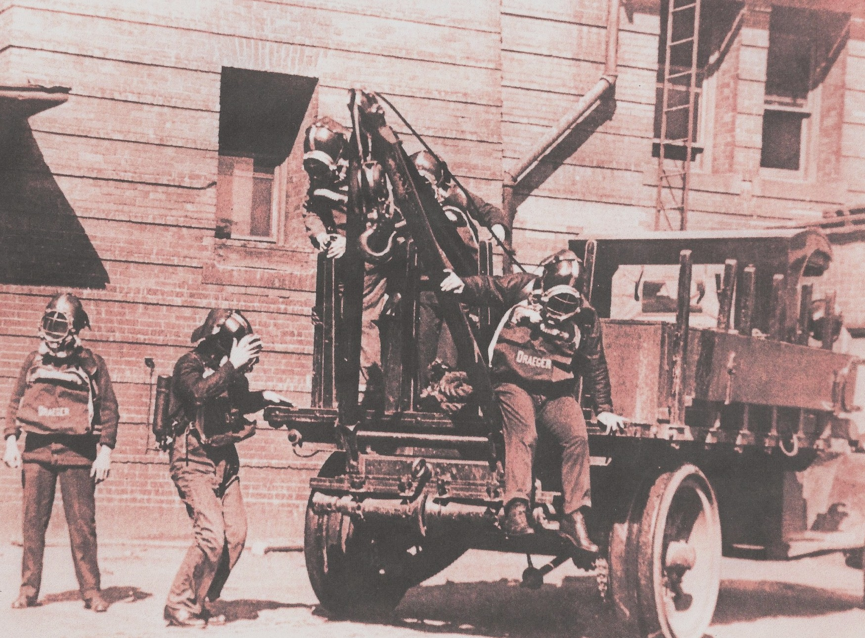
1917 Mack AC “Emergency Truck”, crew wearing Drager style masks. Photos from the collection of
J. Pozark Jr.

If you have any information on the responses of the Emergency Truck, please send them along and we will publish them in the first issue of the Line Box in October.

Have a great summer and stay safe and see you all in September!

